Naaxtech — Landing page block layout
Based on copywriting best practices
Copywriting Crash Course - The Basics 🤗 https://copyhackers.com/free-copywriting-video-tutorials/

Best Landing Pages To Model Specifically

Tech / Systems Feel
- Linear
Good for simplicity but missing CTA buttons above the fold
- Stripe

Enterprise Trust
- Snowflake

Great Copy Structure
- Basecamp
Too wordy, too many chunks of phrases but the structure is good
- HubSpot
Clean and easy to digest

Premium SaaS Feel
- Notion
- Framer
Not bad, a bit messy with the gallery and bit video heavy but the unique value proposition is short and clear “Build better site, faster”
Honestly? If we combine:
- Stripe clarity
- Linear aesthetics
- HubSpot funnel logic
- Basecamp personality
…we get something dangerous. In a good way.

Suggested structure:
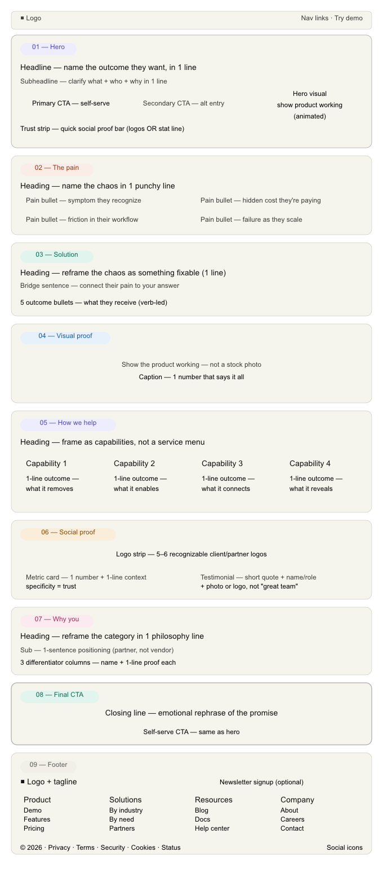
If Naaxtech wants to feel premium, scalable, trustworthy and “holy sh*t these people know what they’re doing”… then the landing page cannot look like:
- another generic AI agency
- another automation bro startup
- another cyber-tech buzzword soup festival
Most tech companies completely fail because they talk about themselves instead of the client’s transformation.
And the bigger the tech… the simpler the copy should become.

First: What SHOULD Naaxtech FEEL Like?
Based on the vibe from “NexTech”-style positioning in cybersecurity, infrastructure, AI, automation, engineering and digital systems
Naaxtech should feel like:
- Intelligent
- Calm confidence
- High-end
- Strategic
- Modern
- Efficient
- Slightly futuristic
- NOT “startup-y”
- NOT overly corporate-dead
Think:
- Stripe
- Linear
- Palantir
- Vercel
- Notion
That tier.

Biggest Mistake To Avoid
DO NOT open with:
“AI-powered digital transformation solutions”
That sentence has killed more conversions than bad WiFi.
Nobody emotionally connects to:
- digital transformation
- synergy
- innovative solutions
- scalable ecosystems
- cutting-edge infrastructure
These phrases mean absolutely nothing anymore.

The Homepage Structure I’d Recommend

SECTION 1 — HERO
This section determines whether people scroll or leave.
You need:
- One HUGE outcome
- One supporting sentence
- One CTA
- One visual

Example Hero Headlines

Option 1 — Strong + Premium
Build Smarter Systems. Scale Without Chaos.
Subheadline:
Naaxtech helps businesses automate operations, streamline workflows, and build technology infrastructure that actually scales.
CTA:
- Book a Strategy Call
- See How It Works

Option 2 — More Enterprise
Technology That Removes Bottlenecks Before They Cost You Growth.
Subheadline:
From automation and AI to operational systems and digital infrastructure, we help businesses run faster, leaner, and smarter.

Option 3 — More Aggressive
Your Business Doesn’t Need More Software. It Needs Better Systems.
That’s the kind of line that makes people stop scrolling.

SECTION 2 — THE PAIN
This is where most companies fail.
You need to IDENTIFY the chaos.
Example:

Heading
Most Businesses Are Held Together With Digital Duct Tape.
Then show:
- disconnected tools
- repetitive admin
- teams wasting time
- data scattered everywhere
- expensive inefficiencies
- systems that don’t scale
Mini bullets:
- Manual processes slowing your team down
- Too many platforms that don’t talk to each other
- Expensive software nobody fully uses
- Operations becoming harder as you grow
Now the user thinks:
“Okay… these people understand my problem.”

SECTION 3 — THE SOLUTION
Now introduce Naaxtech.
NOT:
“We provide innovative technology services.”
Please no. The internet has suffered enough.
Instead:

Heading
We Design Systems That Work Together.
Then explain:
- AI automation
- integrations
- dashboards
- operations
- infrastructure
- custom systems
BUT THROUGH OUTCOMES.
Example:
Reduce repetitive admin.
Connect disconnected tools.
Automate reporting.
Eliminate operational bottlenecks.
Build infrastructure designed for growth.

SECTION 4 — VISUAL PROOF
This is mandatory.
Show:
- dashboards
- workflow maps
- analytics
- automation examples
- integrations
- clean UI
People trust what they SEE.
Especially in tech.
A simple animated workflow diagram alone can massively improve conversions.

SECTION 5 — SERVICES (BUT POSITION THEM DIFFERENTLY)
Don’t call it:
“Our Services”
That screams brochure website from 2012.
Instead:

“How We Help”
or

“Built For Modern Operations”
Then cards like:

AI & Automation
Remove repetitive work and reduce operational friction.

Systems Integration
Connect your tools, data and workflows into one streamlined ecosystem.

Digital Infrastructure
Build scalable foundations that support long-term growth.

Operational Intelligence
Turn scattered data into actionable insights.

SECTION 6 — SOCIAL PROOF
Even if early-stage:
- logos
- metrics
- testimonials
- partnerships
- certifications
- process screenshots
- before/after results
Examples:
Reduced reporting time by 82%
Replaced 14 manual workflows with a unified automation system
Specificity = trust.

SECTION 7 — WHY YOU
This section matters more than founders think.
Example:

Heading
Technology Is Easy. Adoption Is Hard.
Then explain:
- you simplify complexity
- business-first approach
- practical systems
- scalable architecture
- no bloated solutions
This is where positioning happens.

SECTION 8 — FINAL CTA
Not:
Contact us
Too weak.
Instead:

“Let’s Fix The Bottlenecks Slowing Your Business Down.”
CTA:
Book Your Strategy Session
or
Get a Custom Systems Audit
THAT sounds valuable.

The REAL Secret For Naaxtech
Naaxtech should not market:
- AI
- automation
- software
- infrastructure
It should market:
- clarity
- speed
- operational control
- efficiency
- scalability
- reduced chaos
People do not buy “automation.”
They buy:
“I’m tired of this operational mess.”
That distinction is worth millions.

Design Direction
I’d personally go with:

Style
- Dark mode
- Black / graphite / white
- One accent colour only
- Minimal gradients
- Strong typography
- Spacious layout
- Motion only where useful
Think:
- premium control centre
- modern systems dashboard
- “future-ready”
without looking like a crypto scam from 2021.

The BEST Landing Page Type For Naaxtech
Not corporate.
Not agency.
Not startup.
You want:

“Operational Intelligence Partner”
That positioning sits WAY higher-value psychologically.
Agency = outsourced labour.
Partner = strategic growth infrastructure.
Massive difference.

